1. **PURPOSE:**

To provide procedure For Operation and calibration of Carry 630 FTIR.

1. **SCOPE:**

This procedure is applicable to the FTIR following in Quality Control laboratory at Discovery.

Make : Agilent Technologies

Model : Carry 630

Instrument ID No. : DIPL/QC/INS/FTIR/001.

1. **RESPONSIBILITY:**
   1. Analyst-QC shall be responsible to follow this SOP.
   2. Head-QC/Designee shall be responsible for ensuring implementation of this SOP.
   3. Head-QA/Designee shall be responsible for monitoring overall compliance of this SOP.
2. **DEFINITIONS:**

Nil

1. **PROCEDURE:**
   1. **Operation:**

Check that the instrument is clean and free from dust, if not clean with a soft cloth duster.

Double click on Mircolab pc.

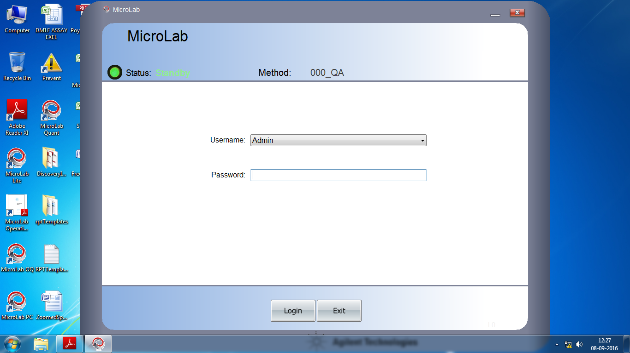

Enter the password the above screen will appear

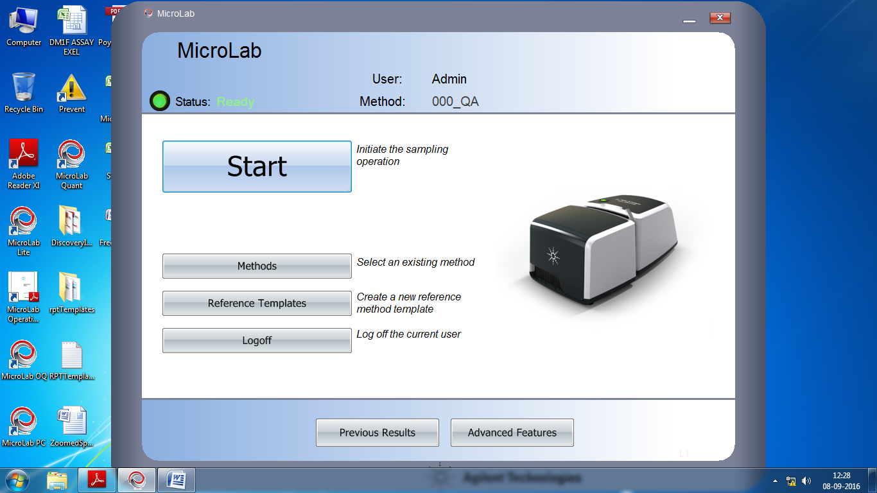

* 1. **How to create data collect**

Double click on method and select default method →Select type Method type →Data collect only → and select Y axis units→ Transmittance

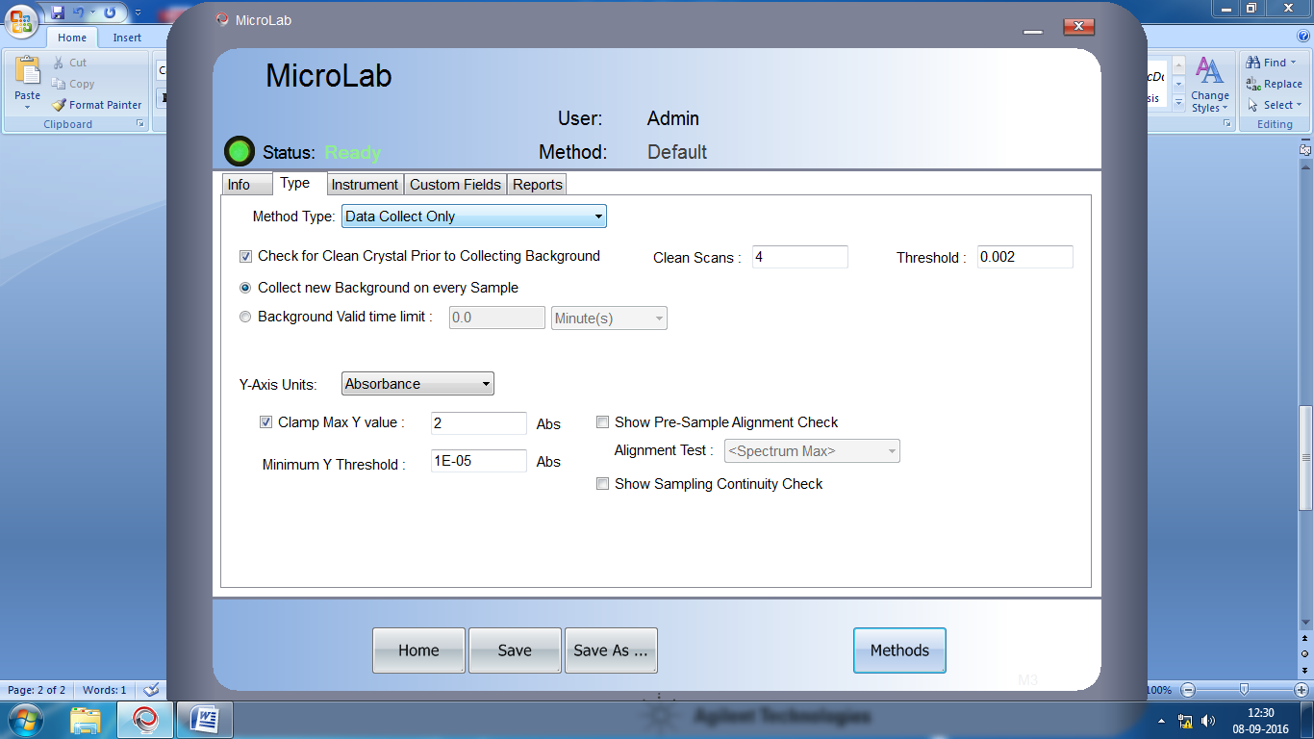

Select Instrument give required range→ Select range → Spectral range→ (3800-650) → Back ground scans → by default (32)

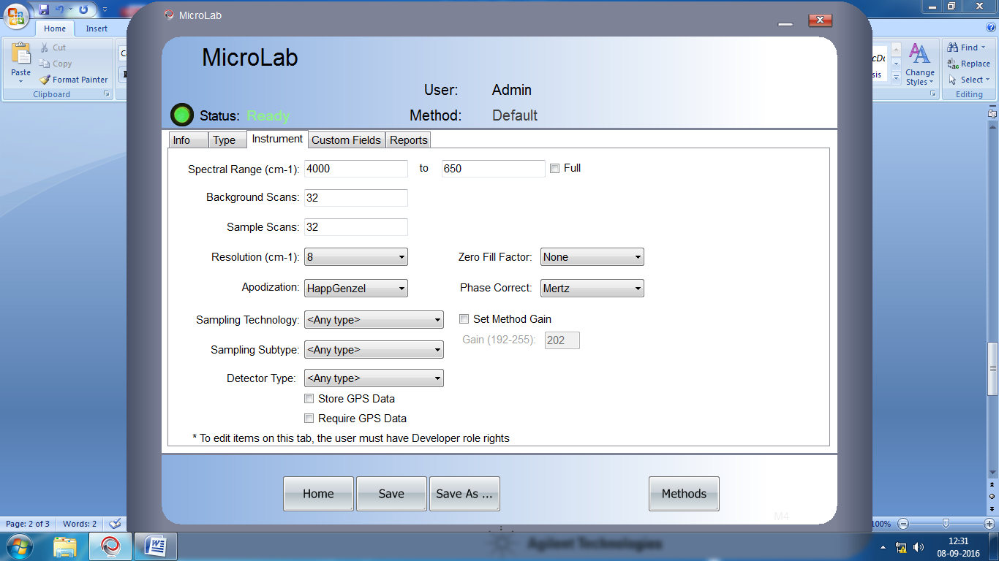

Select custom filed is not required.

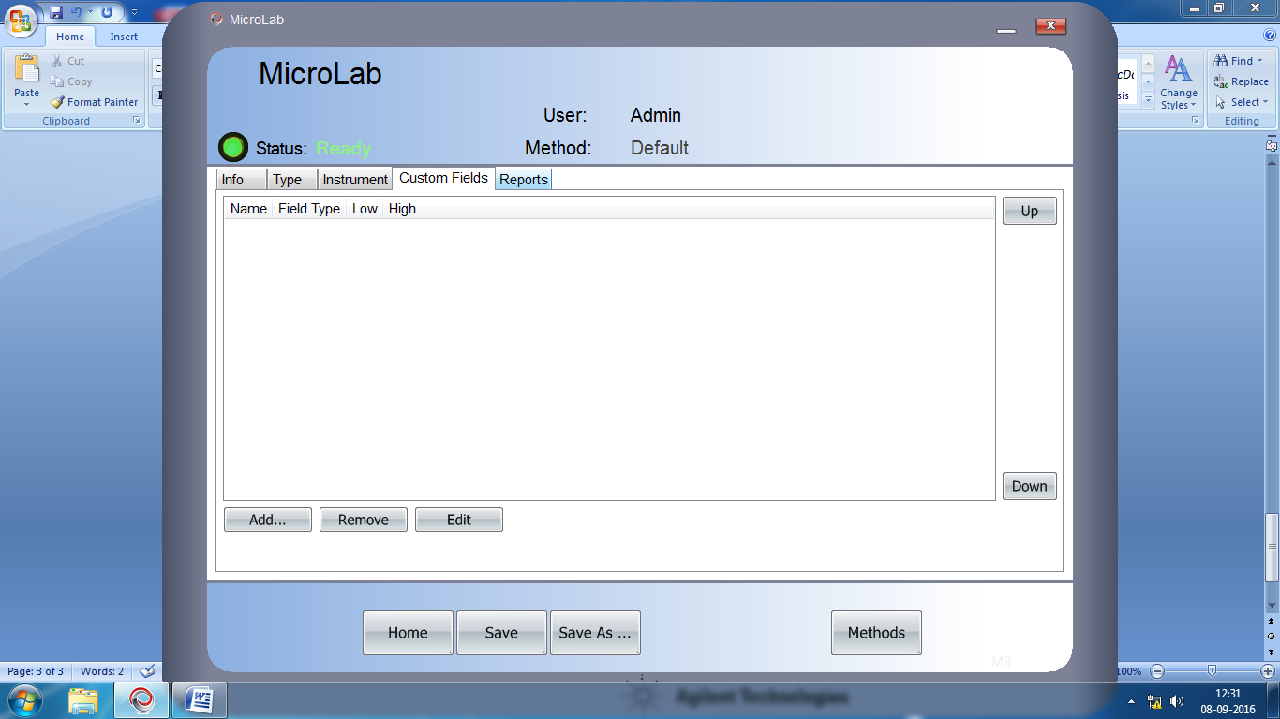

Select report template add the spectrum left to right side.

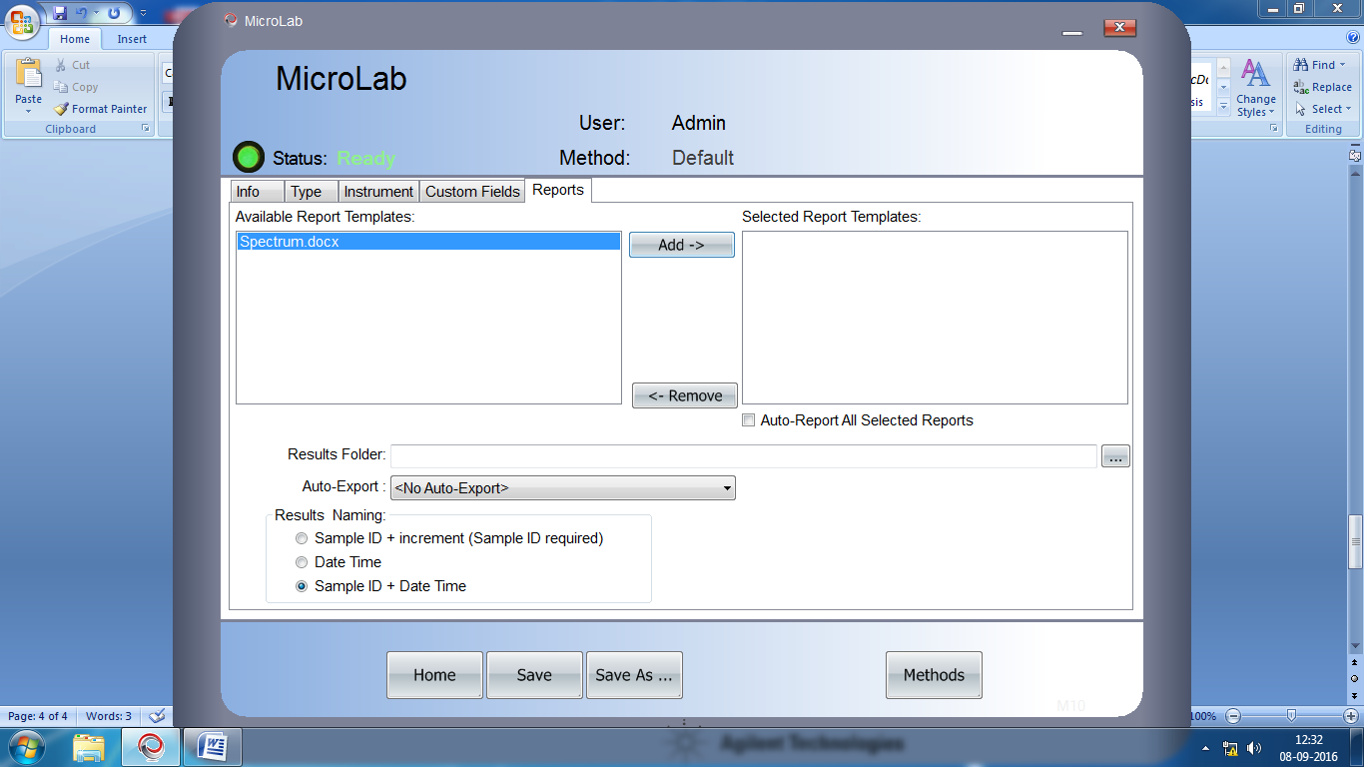

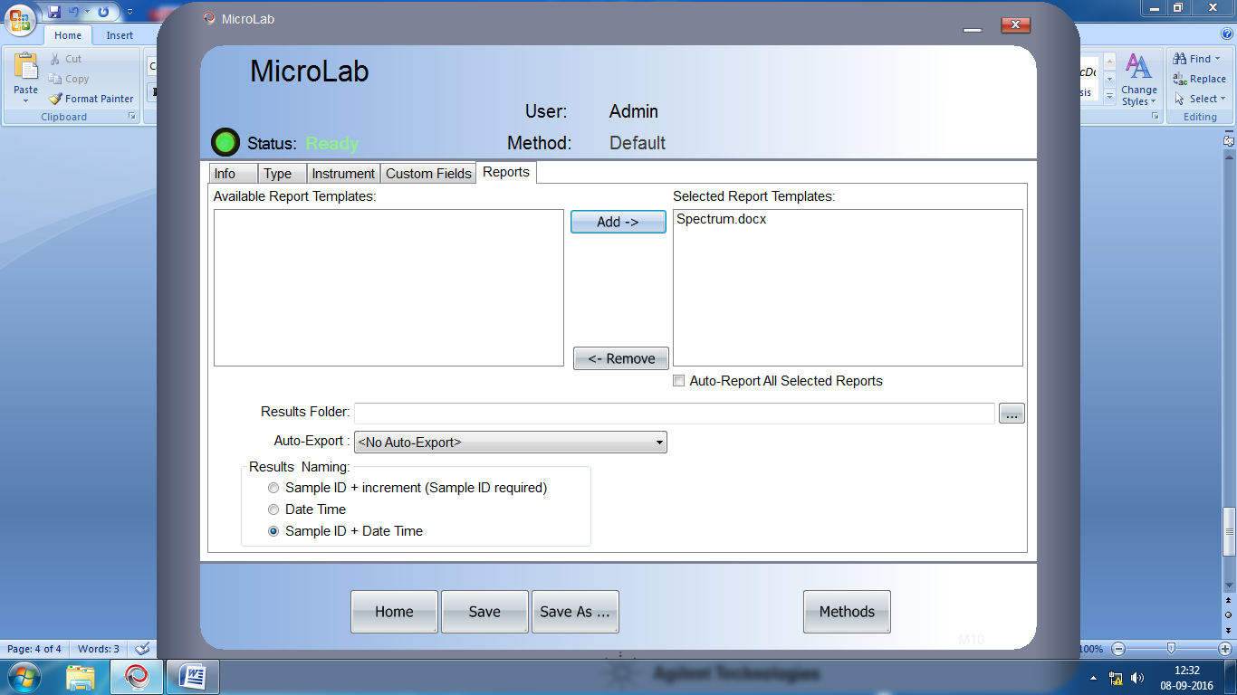

Save as the method give the method name, activate the method.

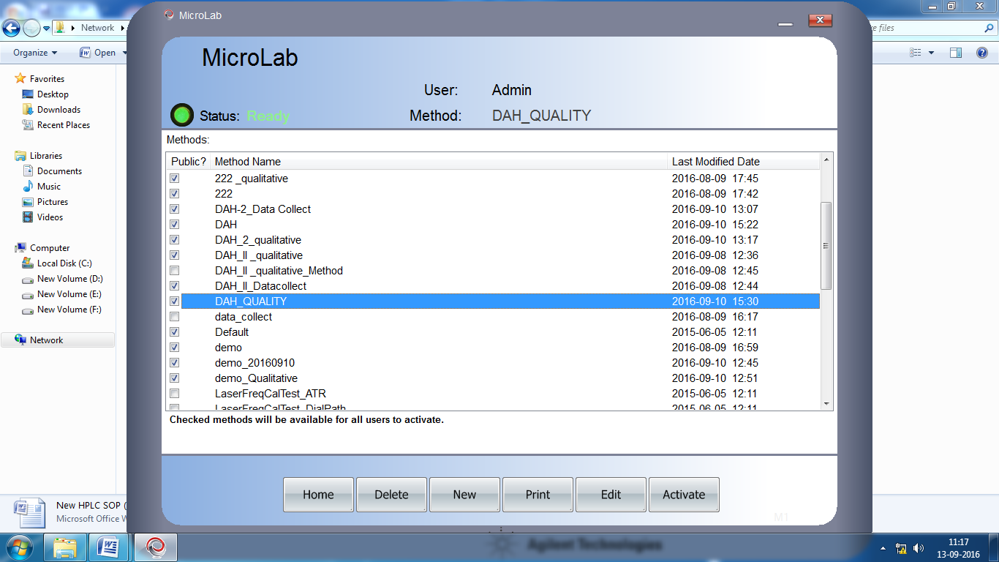

Click the start button

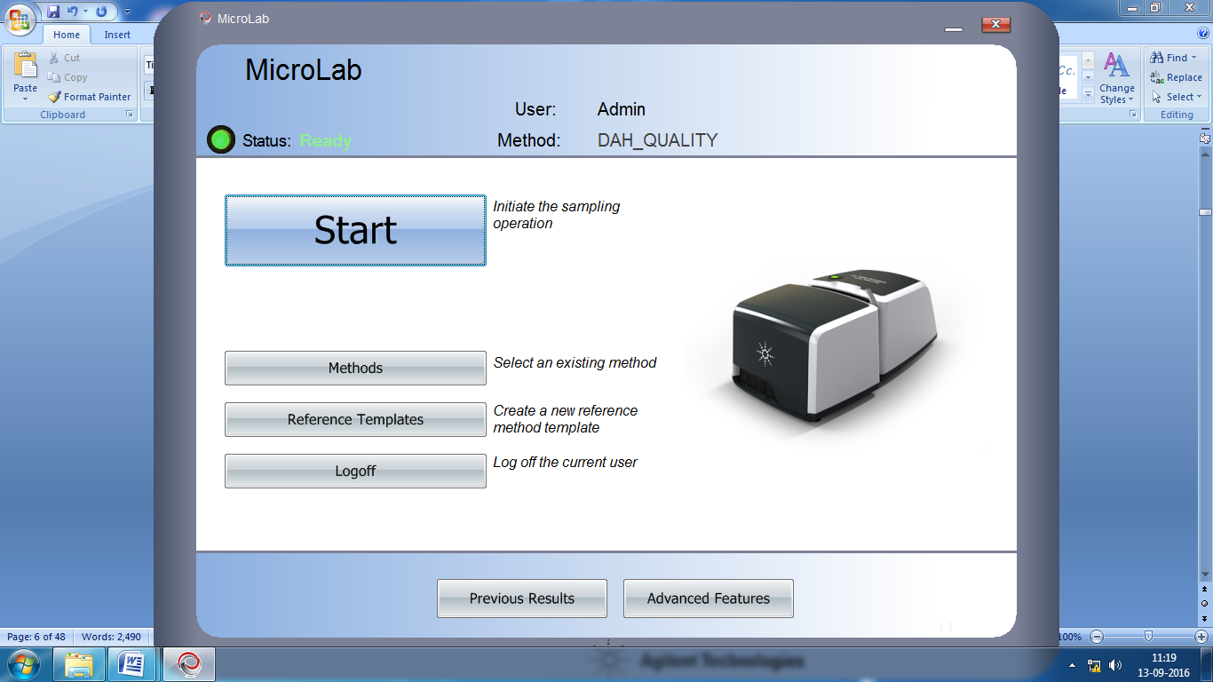

Prepare the background by using potassium bromide and click next.

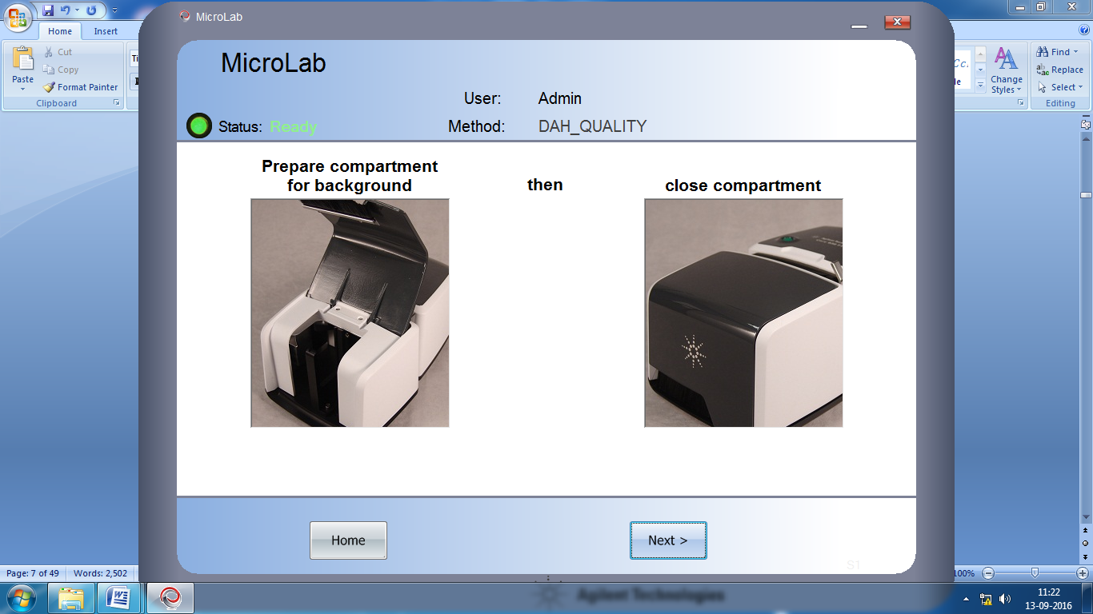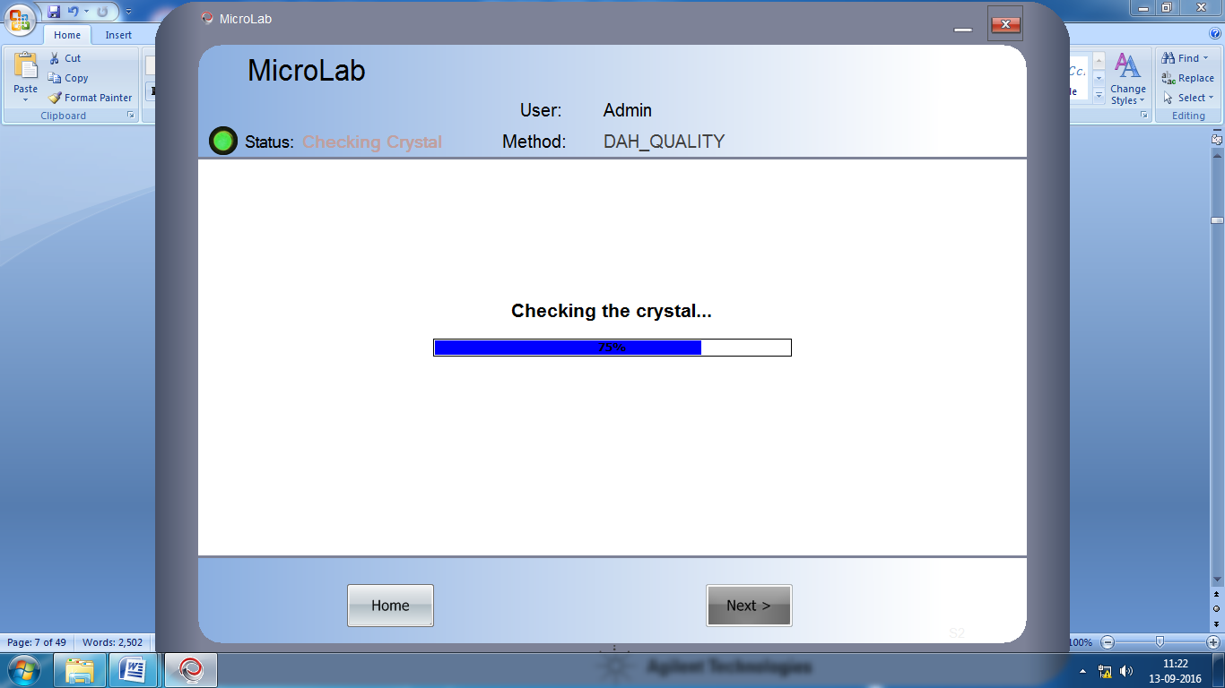

After collecting background prepare the sample and put the holder in sample compartment and click Next button.

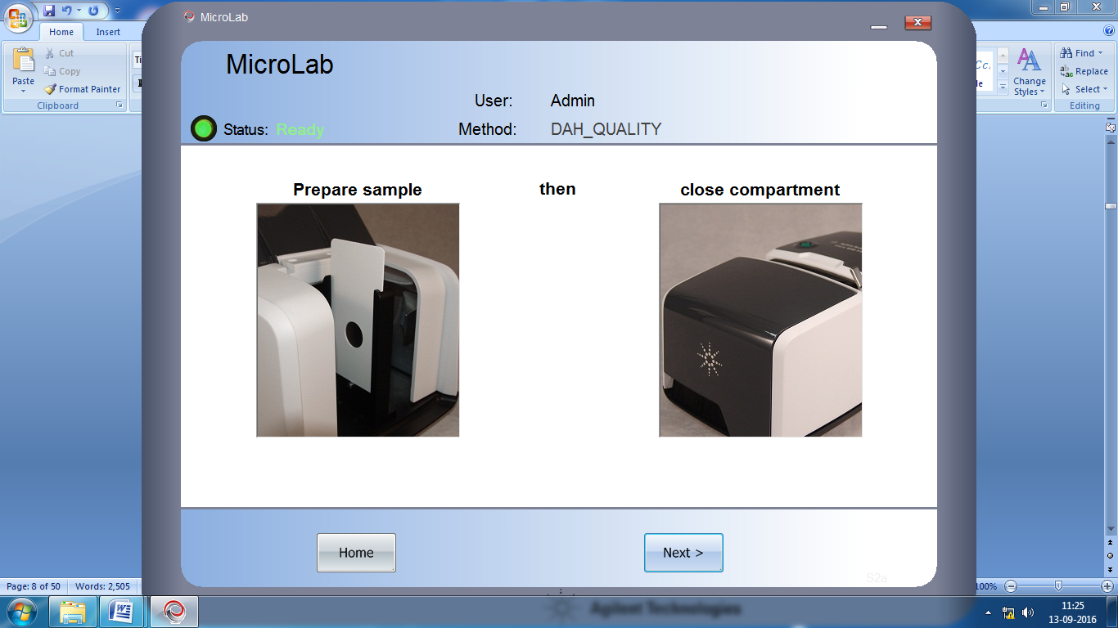

Collect the spectrum and give the sample ID

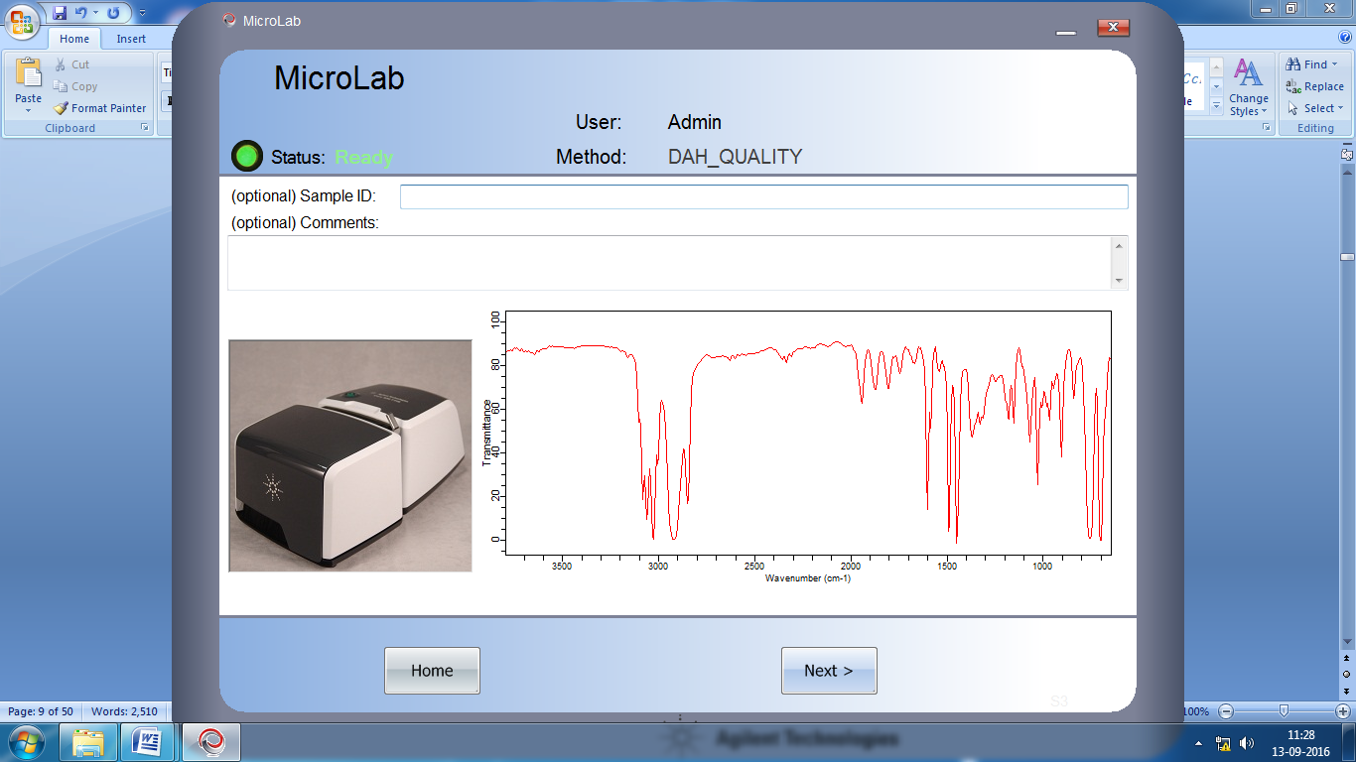

After collecting the spectrum and record the spectrum

* 1. **How to create library**

Click the home button and select advance future.

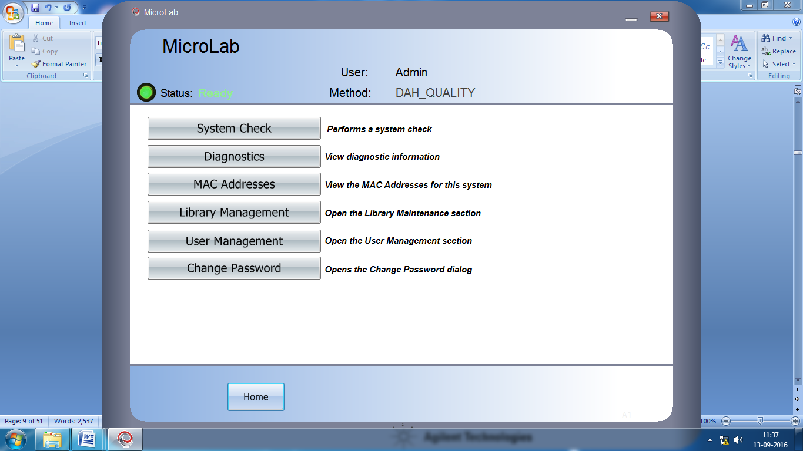

and click the library management→select the new library

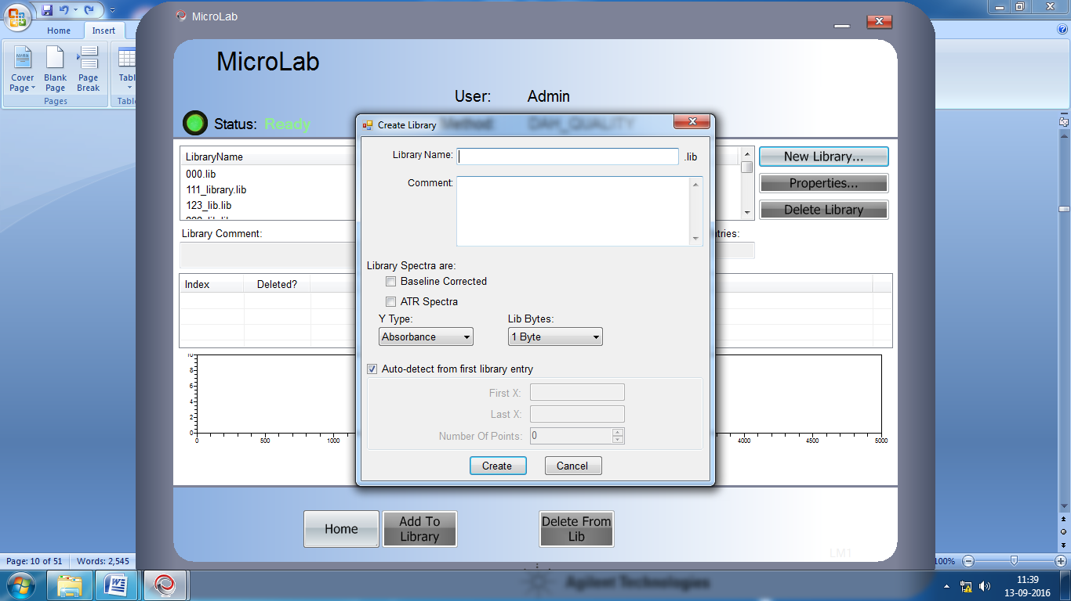

Give the library name and select Y Type → select transmittance and click the create new librarty. Click view button and go to the data handling → click add to library

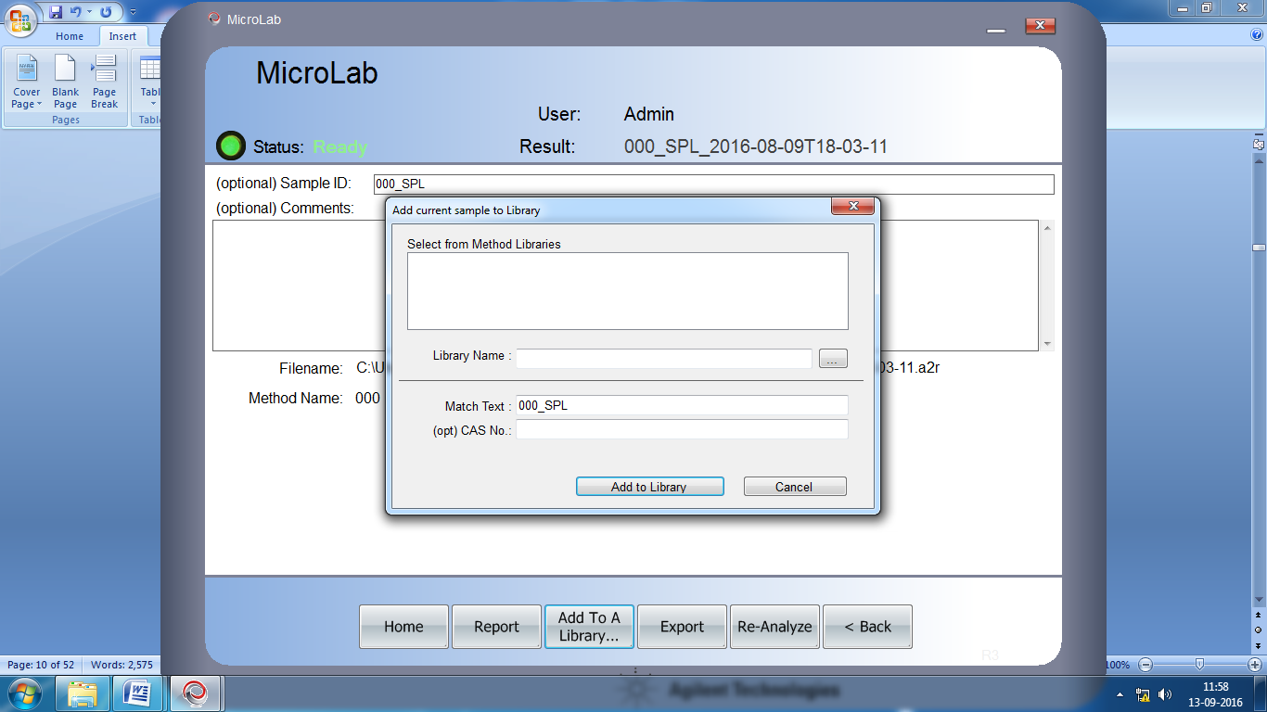

Add to library, click the report the button, and take the report.

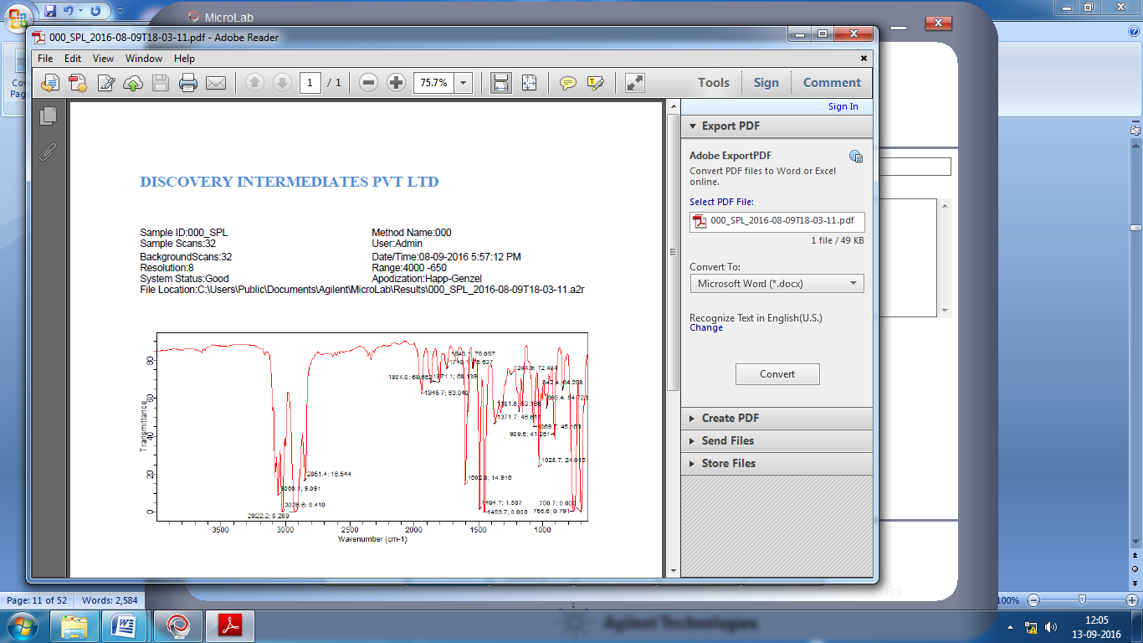

Select Home method →select the method →edit →Type→ Method Type → Qualitative search and Y axis units Transmittance.

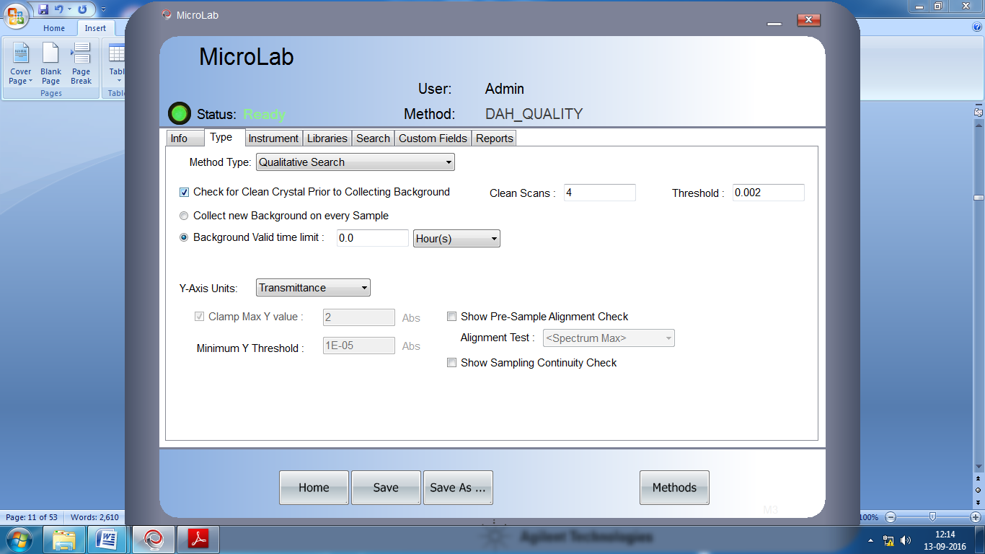

Click instrument button → give the spectral range and back ground scans.

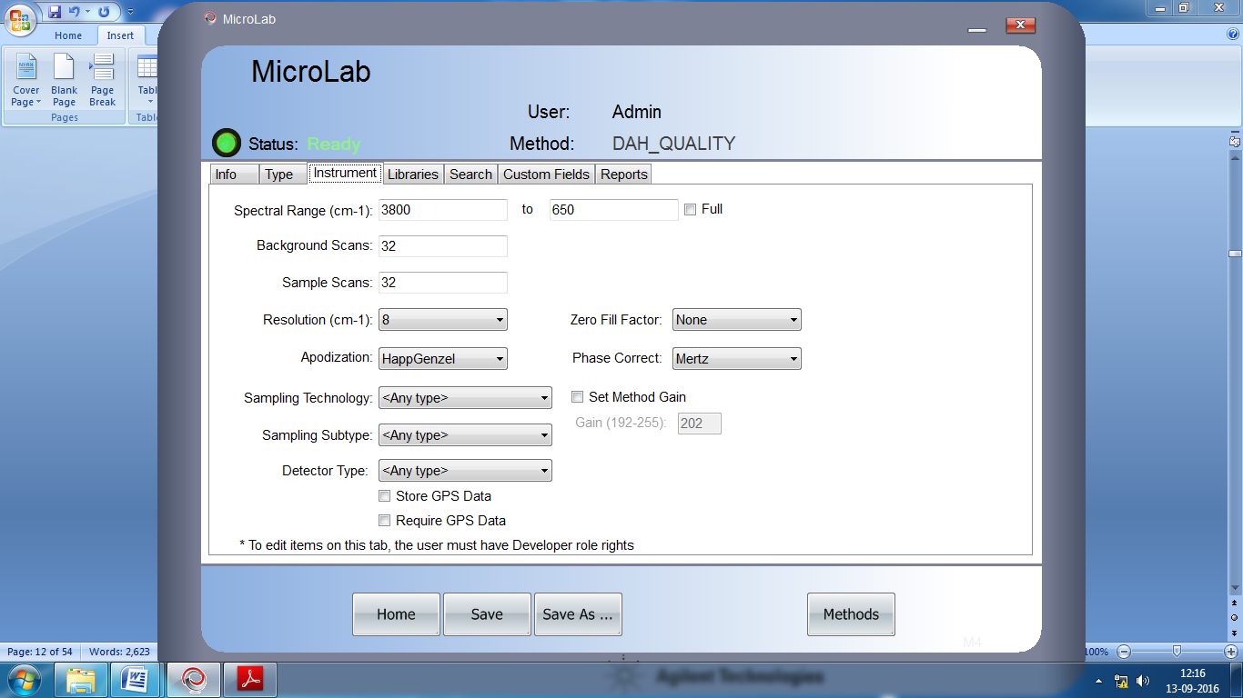

Select the library button and add the library button

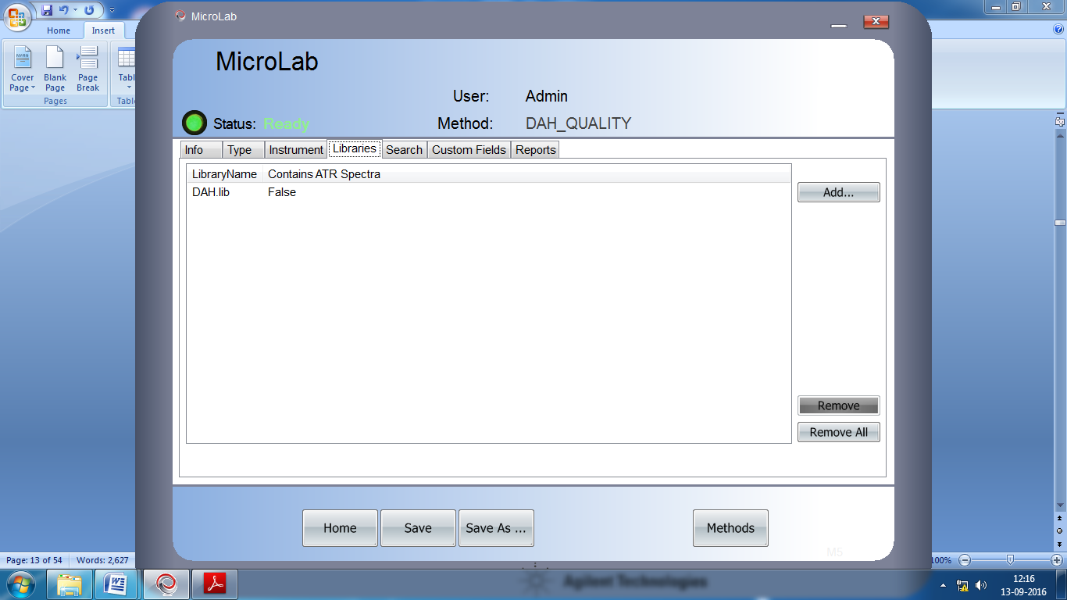

Click the report button add available report template to right to left

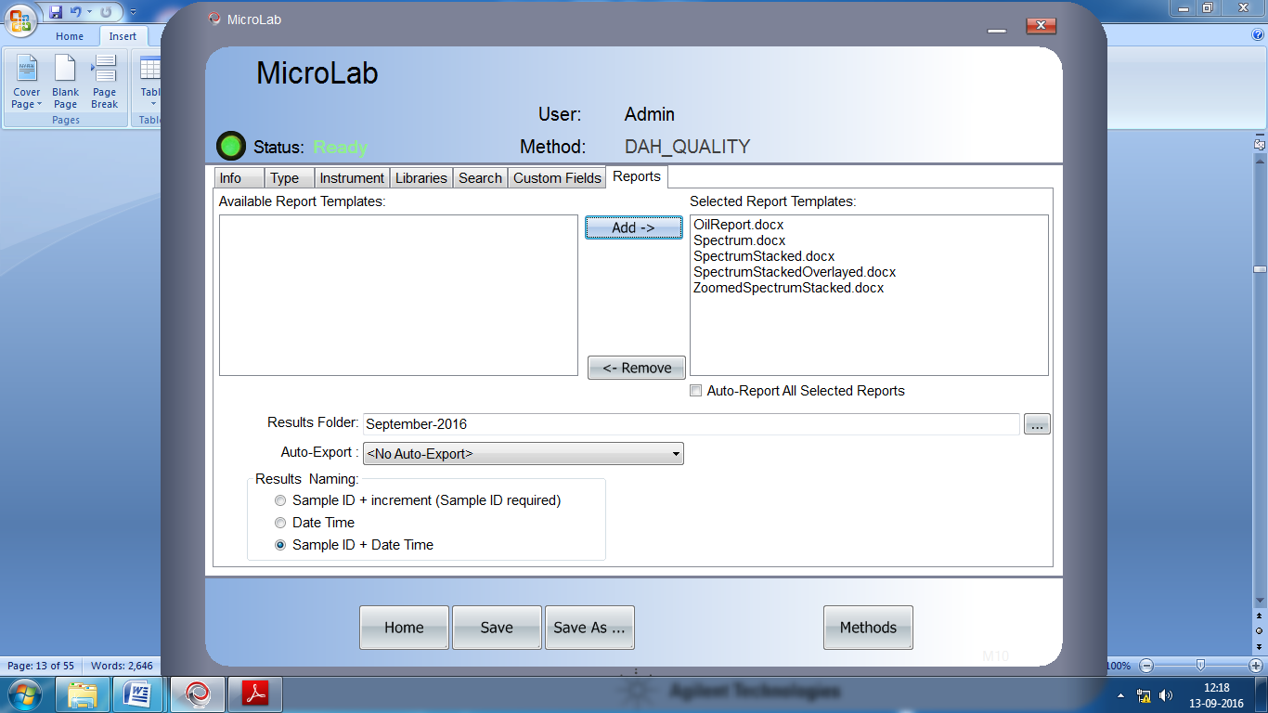

Save as the method and go to the home and select the qualitative method and click the activate button start button is blinking click the start button.

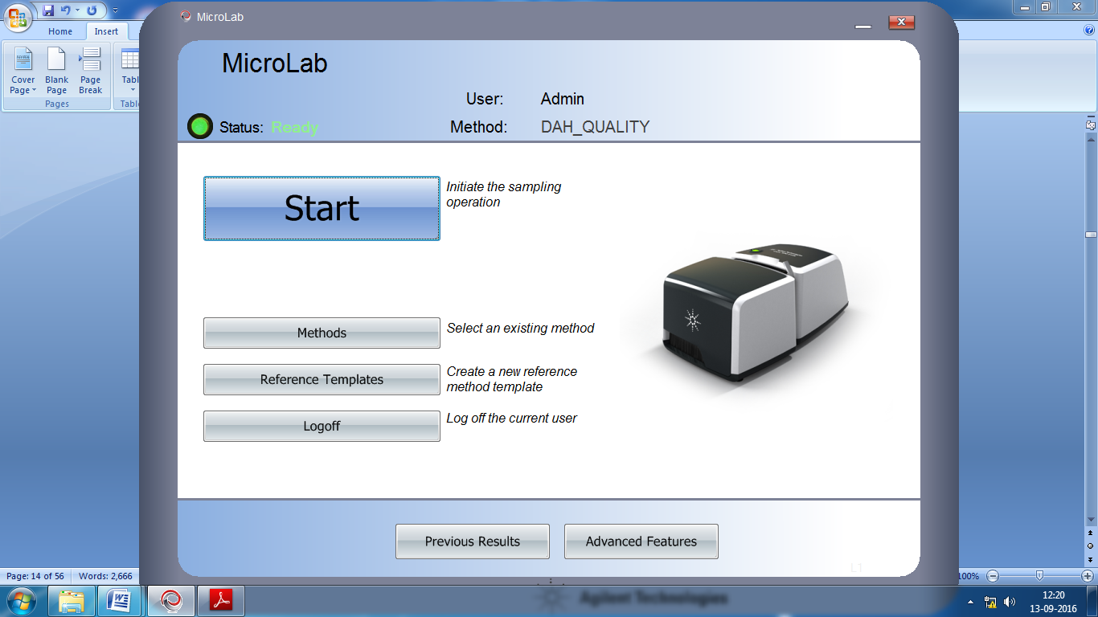

Collect the background put the blank Kbr pellet click the next button

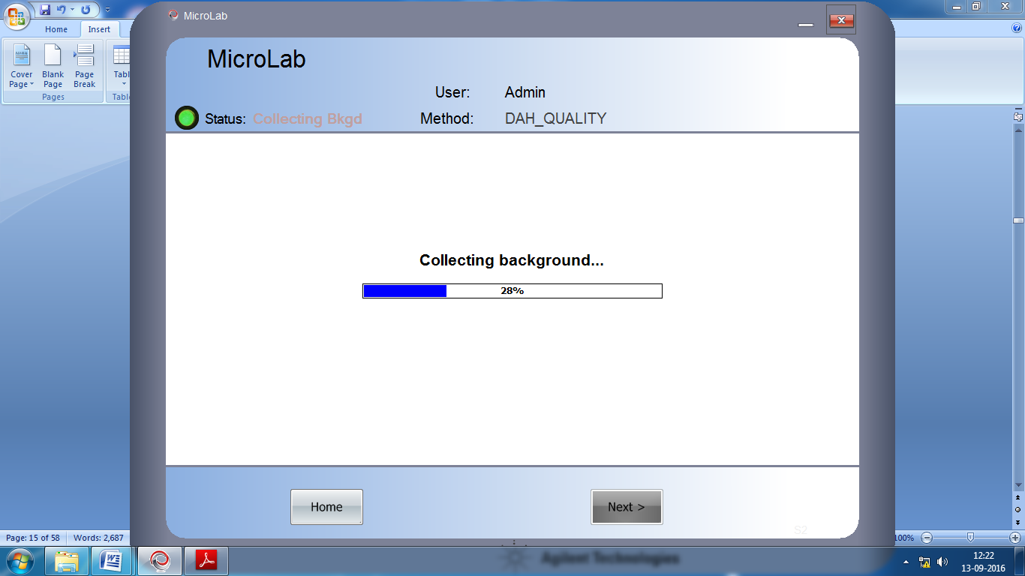

After collecting background prepare the sample

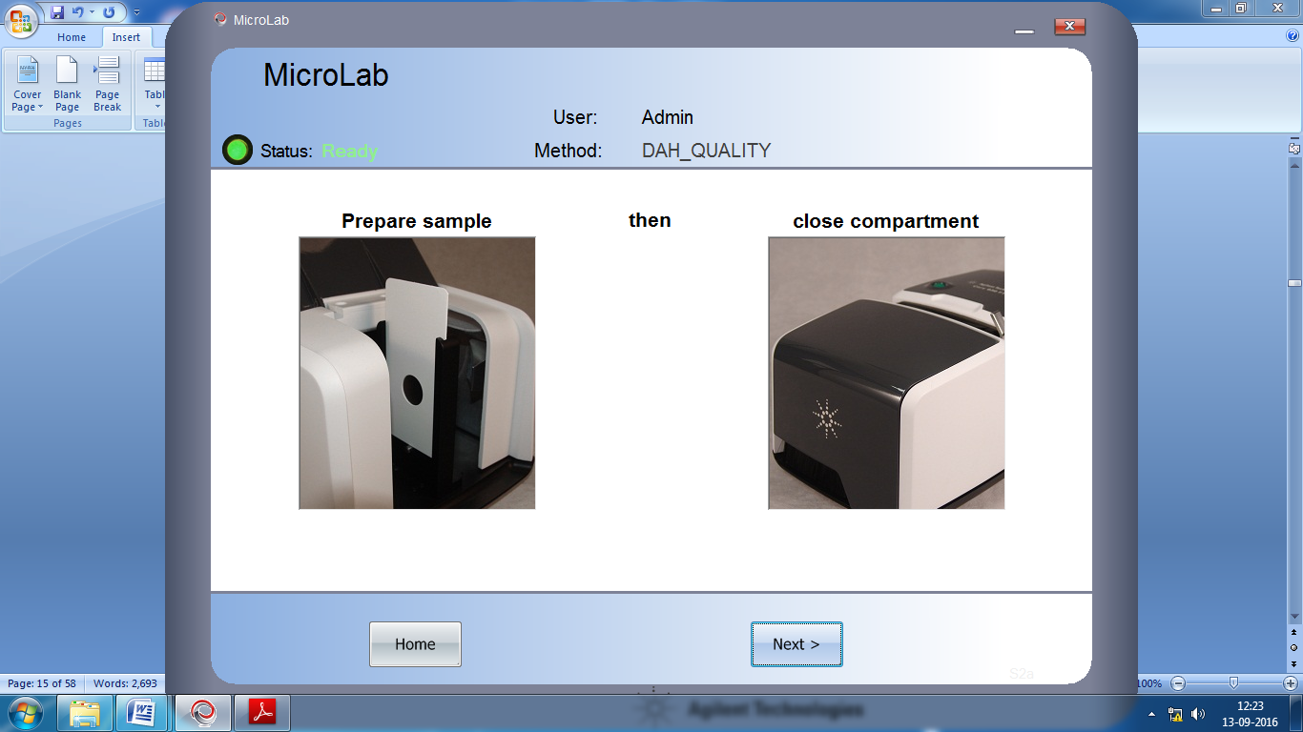

Click the next button and give the sample name and collecting the sample and go to the data handling and click the report button and select the spectrum stacked and print.

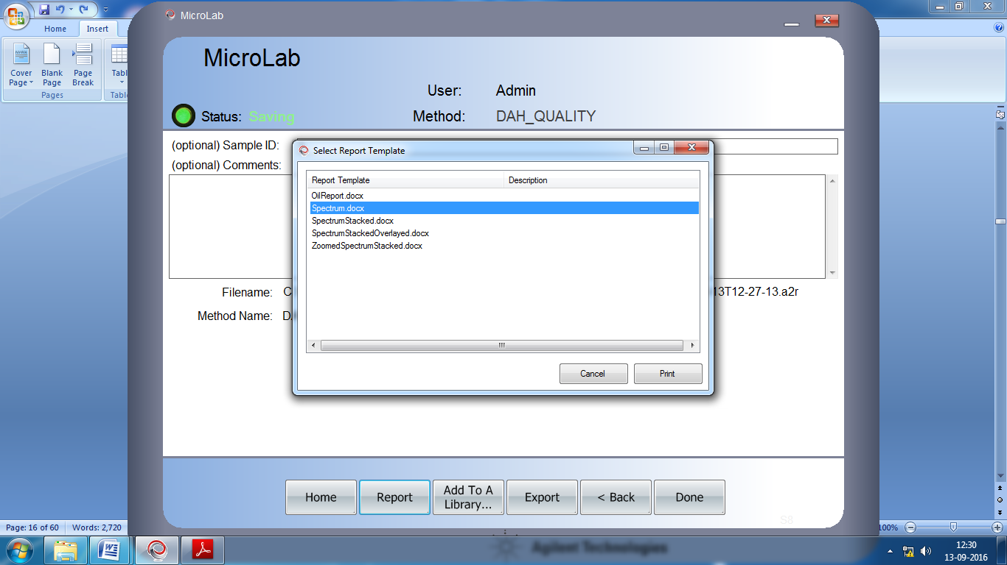

* 1. **Calibration of FTIR:**

**Frequency:** Every 4 months.

Double click on Microlab OQ the below screen will appear

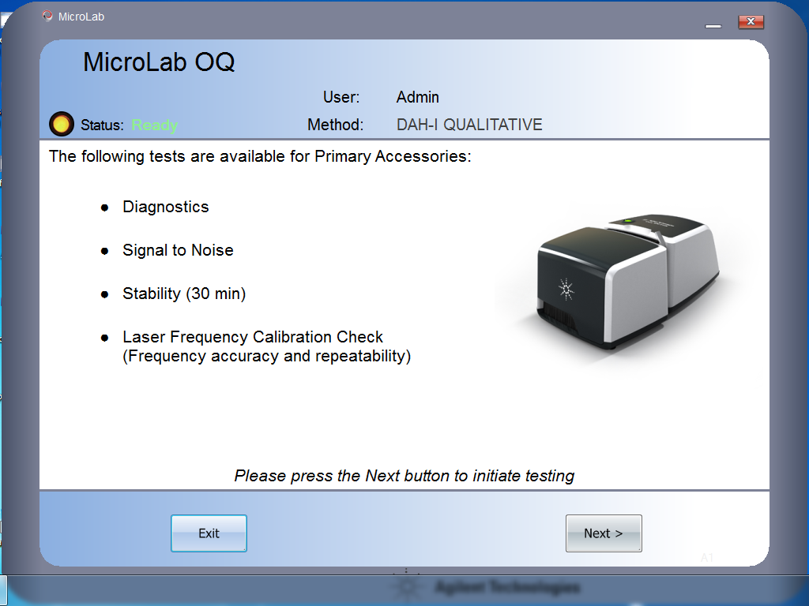

Click on next button the below screen will appear

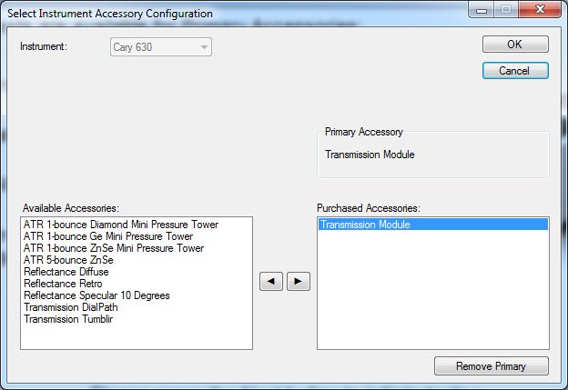

Click on ok the below screen will appear diagnostic verification test should be pass

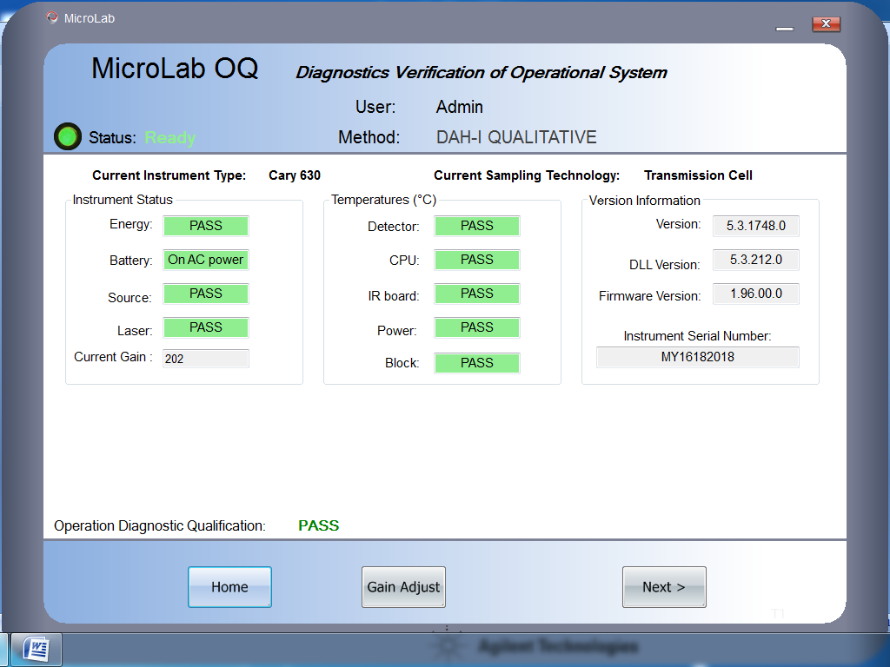

Click the next button the below screen will appear is open and tick mark the performance (signal to-Noise), Stability test, Laser Frequency calibration check. First two parameter is not required for polystyrene.

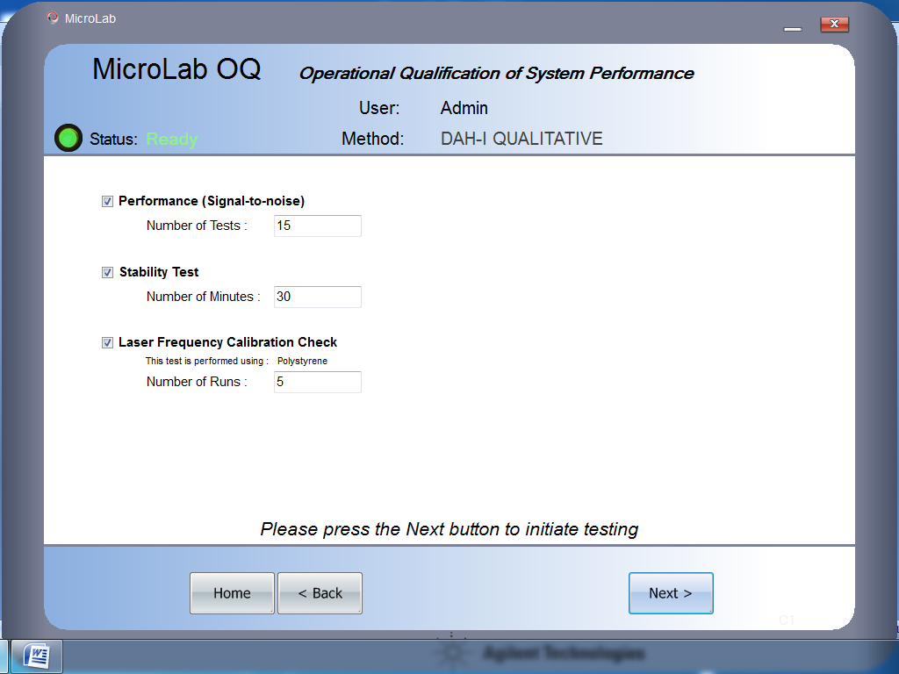

* + 1. Performance (Signal-to-noise)

Number of tests: 15

Specification: >20000

* + 1. Stability Test:

Number of Minute: 30

Specification: <1%

* + 1. Wave number Accuracy test:

(Polystyrene ASTM 1921B)

Number of Runs: 5

Spec. Wave number: 3082.10 1601.35 1583.35 1028.50

Spec. Accuracy : <0.30 <0.30 <0.10 <0.30

Spec Repeatability : <0.05 <0.05 <0.05 <0.05.

1. **FORMATS / ANNEXURE(S):**
   1. Instrument Usage log Book : QC044-FM075
   2. FTIR Calibration Record : QC048-FM086
2. **CHANGE HISTORY:**

| **Revision No.** | **Effective Date** | **Details of Revision** | **Ref CCF No.** |
| --- | --- | --- | --- |
| 00 | 16.9.2016 | New SOP introduced | -- |
| 01 | 01.01.2017 | SOP format changed make to in line with SOP-QA-001-04. | QC-CRF-025/16 |